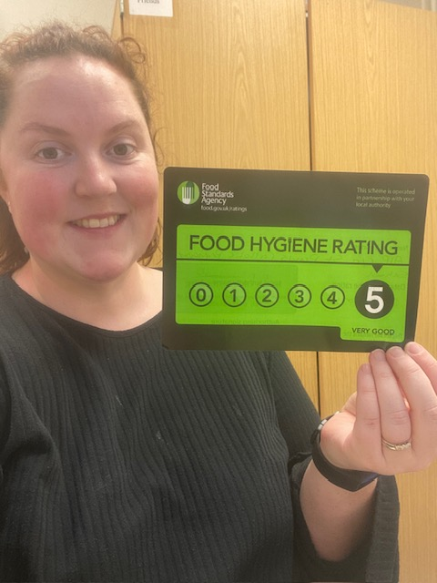

Bridie Hill (Kitchen Manager) with today’s (22.01.24) 5 star Environmental Health Certificate